FLOWER DELERIVERY SYSTEM



SUBMITTED BY,
LUCY MBITHE
DIT

A SYSTEM DOCUMENTATION AND SUBMITTED IN PARTIAL FULFILMENT FOR THE AWARD OF A DIPLOMA IN INFORMATION TECHNOLOGY BY ZETECH UNIVERSITY
AUGUST, 2025

Declaration

The contents of this document are a product of my own personal research as guided by the unit lecturer and following the provided standards of the system proposal document. No content has been plagiarized and all foreign sourced materials have been properly cited and referenced using the APA 7 standard. This document has not been presented or submitted to Zetech University or to any other body in this version. It is an original version.

Student name: __________________________________ Sign: __________________
Supervisor’s name: ______________________________ Sign: __________________
Unit lecturer’s name: _____________________________ Sign: __________________

Dedication

I dedicate this work to my beloved mother, sister, and brothers, whose consistent support and love have been my greatest strength. Their encouragement and sacrifices have fueled my determination and their unshakeable belief in me has been my inspiration.

ACKNOWLEDGMENT

I would like to thank my unit lecturer, Mr. Francis Mutuku, for assisting me in reflecting on different research problems, identifying a feasible one, and coming up with a viable research topic. His weekly class and individual guidance were invaluable in conducting research, gathering data, compiling the system proposal document to its end, and writing the system documentation. I would also like to extend my gratitude to my supervisor, Madam Nancy, for her insightful feedback and support throughout the development of this project. Her expertise and encouragement were crucial in refining the project and ensuring its successful completion. Additionally, I appreciate the support and understanding of my family and friends during this process. Their encouragement and patience provided me with the motivation to complete this work. Thank you all for your contributions and support.

Abstract
The system enables a flower company to manage sales and deliveries efficiently through a centralized online platform. Customers can browse available flower products, place orders, schedule deliveries, and make payments with ease. By providing a direct channel between the company and its customers, the system improves convenience and ensures timely delivery of fresh flowers. Technology supports key processes such as order management, delivery tracking, and customer notifications, making operations more reliable and transparent. This not only enhances customer satisfaction but also helps the company streamline its workflow and expand its reach. Overall, the system creates a modern and efficient solution for flower selling and delivery.

Table of Contents
Chapter One: System Overview 8
1 Research Problem 8
1.1 System Objectives 8
1.2 System Scope 8
1.3 System Justifications 9
Chapter Two: Higher Level Design 10
2.1 : FRONT END (USER INTERFACE) IMPLEMENTATION 10
2.1.0 Login page 10
2.1.1 Create account page 11
2.1.2 Home Page 13
2.1.3 Post Page/ Admin Page 15
2.1.4 Content page 16
Cart page 17
Cart UI code 18
My orders/Profile Page UI 19
Chapter Three: Backend (Logic ) Implementation 21
Chapter Four: Conclusion And Recommendations 34

List of Figures

Figure 1: Login page 9
Figure 2Login UI code 10
Figure 3: create account page 11
Figure 4Create page UI 12
Figure 5Main page 13
Figure 6Home UI 13
Figure 7Admin page 14
Figure 8Admin models register 15
Figure 9Content page 15
Figure 10Shop page 16
Figure 11Cart UI 17
Figure 12: Cart UI code 17
Figure 13orders 18
Figure 14: Orders code 19
Figure 15: Authorization Flowchart 21
Figure 16: Create account code 22
Figure 17: Login flowchart 23
Figure 18: Log in code 24
Figure 19: Post flowers 25
Figure 20: Database models presentation 29
Figure 21: Users table 30
Figure 22: Flowers table 30
Figure 23: Orders table 31
Figure 24: Database Integration 32

Chapter One: System Overview

1 Research Problem
In my community, customers face challenges when buying flowers, such as limited access to fresh and diverse products, unreliable delivery services, and time-consuming purchasing processes. These challenges reduce customer satisfaction and hinder the growth of flower businesses. To address this, there is a need for a centralized digital platform where customers can conveniently order flowers from a single trusted company, schedule deliveries, and track their orders in real time.

1.1 System Objectives

1.1.1 General Objective
To propose and develop a reliable digital platform for flower selling and delivery.

1.1.2 Specific Objectives
(i) To develop an online platform that allows customers to browse, select, and purchase flowers directly from the company.
(ii) To implement a delivery management system that ensures timely and accurate deliveries to customers.
(iii) To provide customers with order tracking, scheduling, and notifications for improved convenience.
(iv) To build an efficient backend system that helps the company manage products, orders, and deliveries effectively.

1.2 System Scope
The proposed platform aims to address the challenges in flower sales and delivery by providing a comprehensive digital solution focused on efficiency, reliability, and customer satisfaction. The system will include the following key components:
- User Registration and Authentication: A secure login and registration feature to allow customers to create accounts and access personalized services.
- Order Placement and Payment: Customers will place orders and schedule deliveries.
- Mobile Compatibility: The platform will be optimized for mobile use, enabling customers to access services anytime and anywhere.

1.3 System Justifications
The system provides customers with a convenient and reliable way to buy flowers and have them delivered to their preferred locations. It simplifies the purchasing process, saves time, and ensures access to fresh products. For the company, the system streamlines operations by managing orders, inventory, and deliveries efficiently. Technology plays a vital role by automating key processes such as order tracking and customer notifications, which improves transparency and trust. Overall, the system enhances customer satisfaction, increases business reach, and creates a modern solution for flower selling and delivery.

Chapter Two: Higher Level Design

2.1 : FRONT END (USER INTERFACE) IMPLEMENTATION

2.1.0 Login page
The figure below represents a login page interface, This is the Landing page of my system

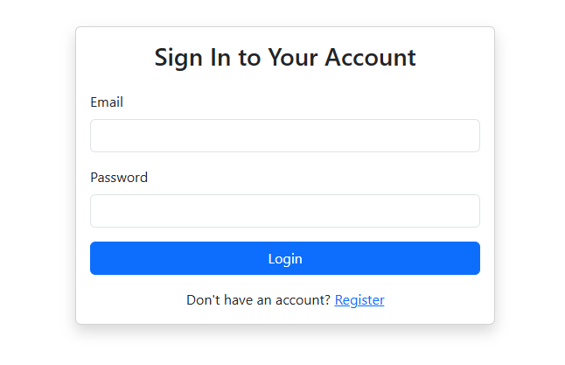
Figure 1: Login page

2.1.0.1 Login generator code
This is UI code generated the login page

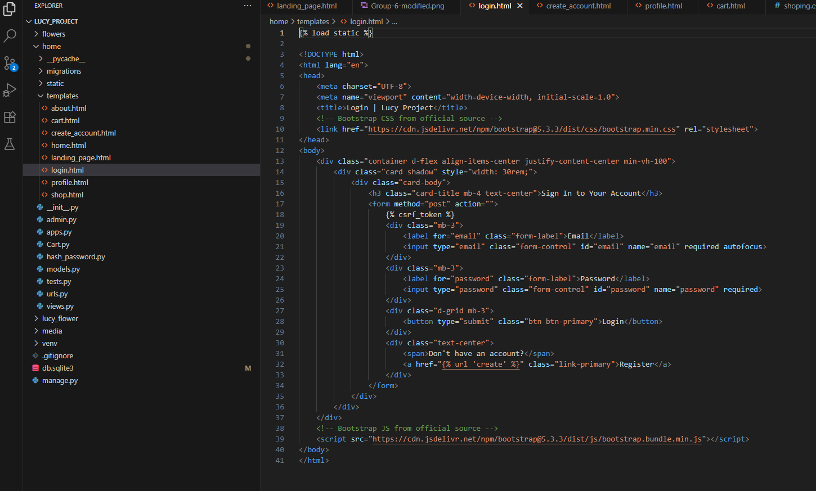
Figure 2Login UI code

2.1.1 Create account page

Below represent account creation page of my system. For you to log in you must have ever passed through this page

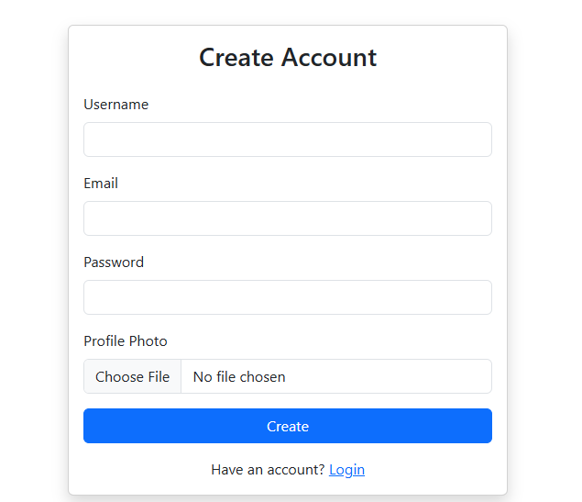
Figure 3: create account page

2.1.1.1 Create account page
Below is create account UI code

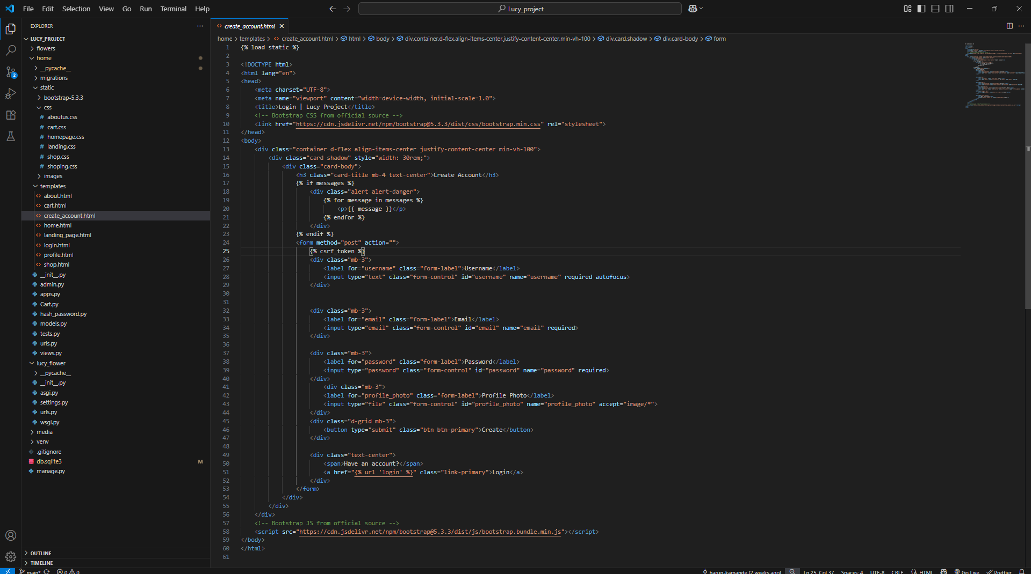
Figure 4Create page UI

2.1.2 Home Page

This is what my system will display incase you provide valid credential in the login page.

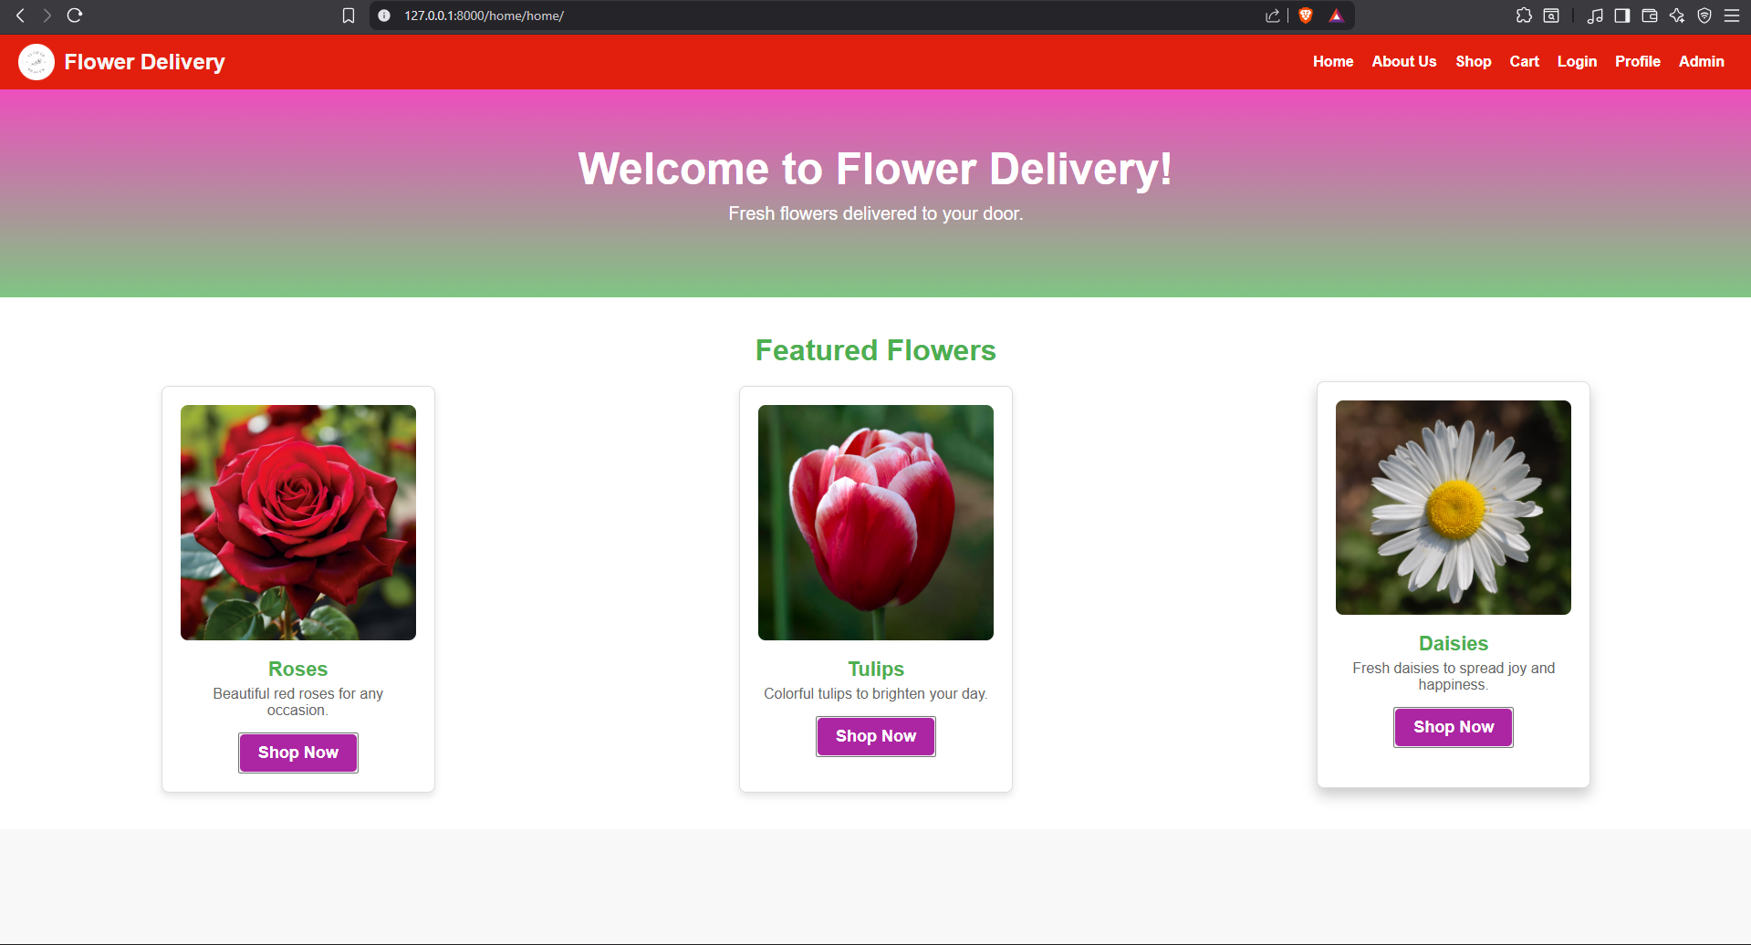
Figure 5Main page

2.1.2.1 Home Page UI code
Home page generator code
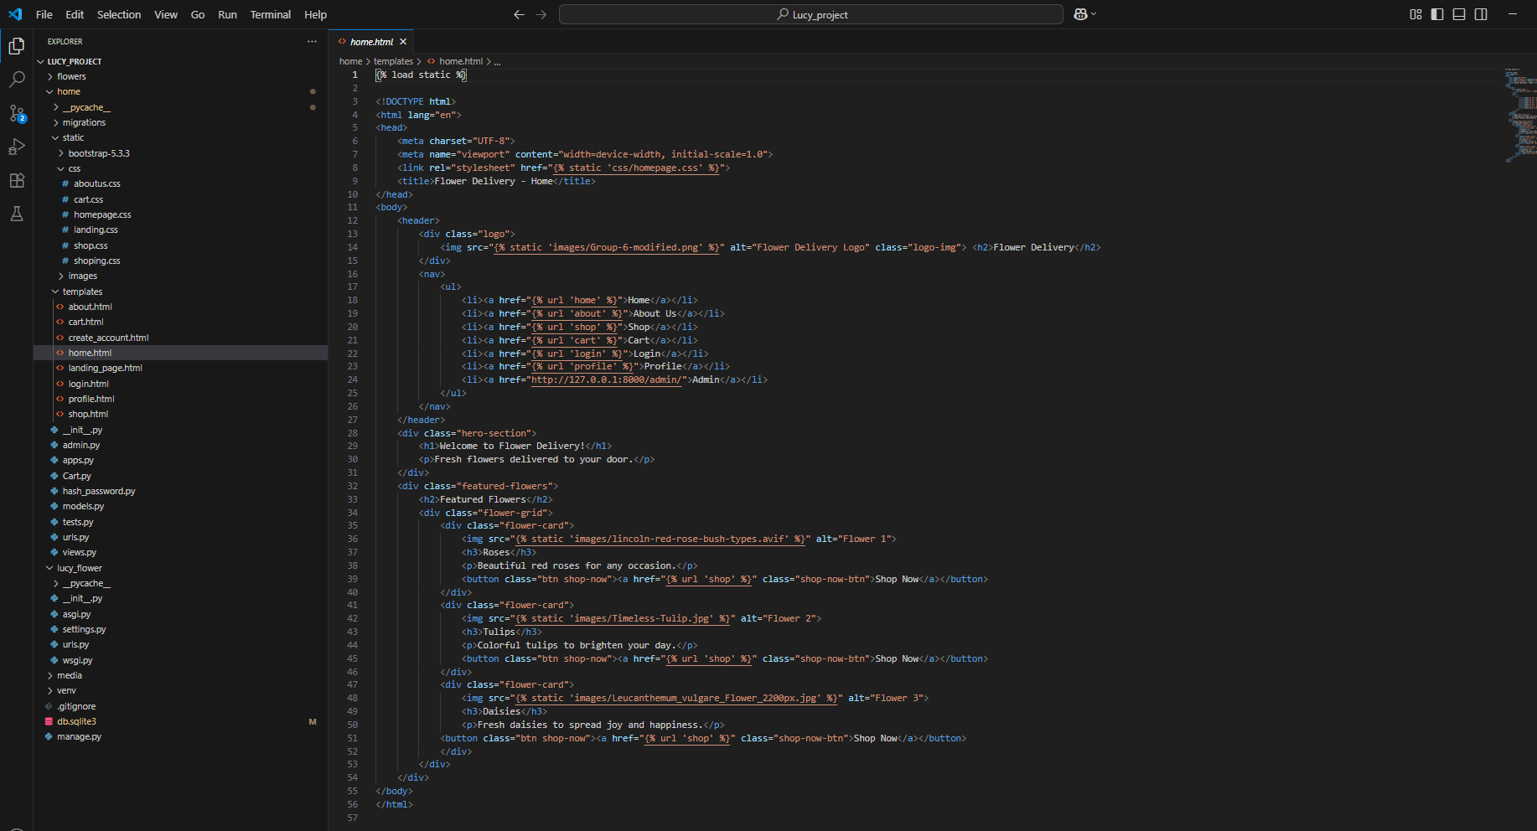
Figure 6Home UI

2.1.3 Post Page/ Admin Page

Below is the admin page, where admin can perform his administration activities that include posting flowers, delivery confirmation or even price altering

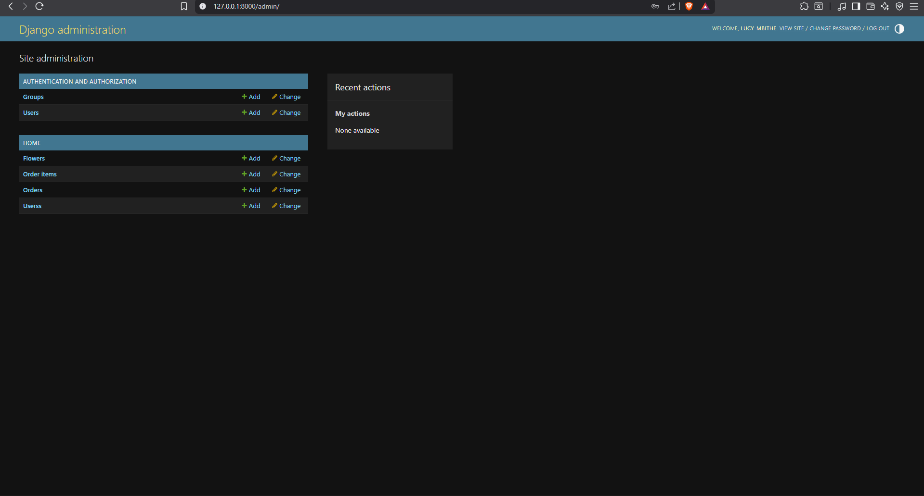
Figure 7Admin page

2.3.1.1 Admin code
In Django Admin page and capabilities are provided by default, so the only thing you have to do is to regester your models as shown below

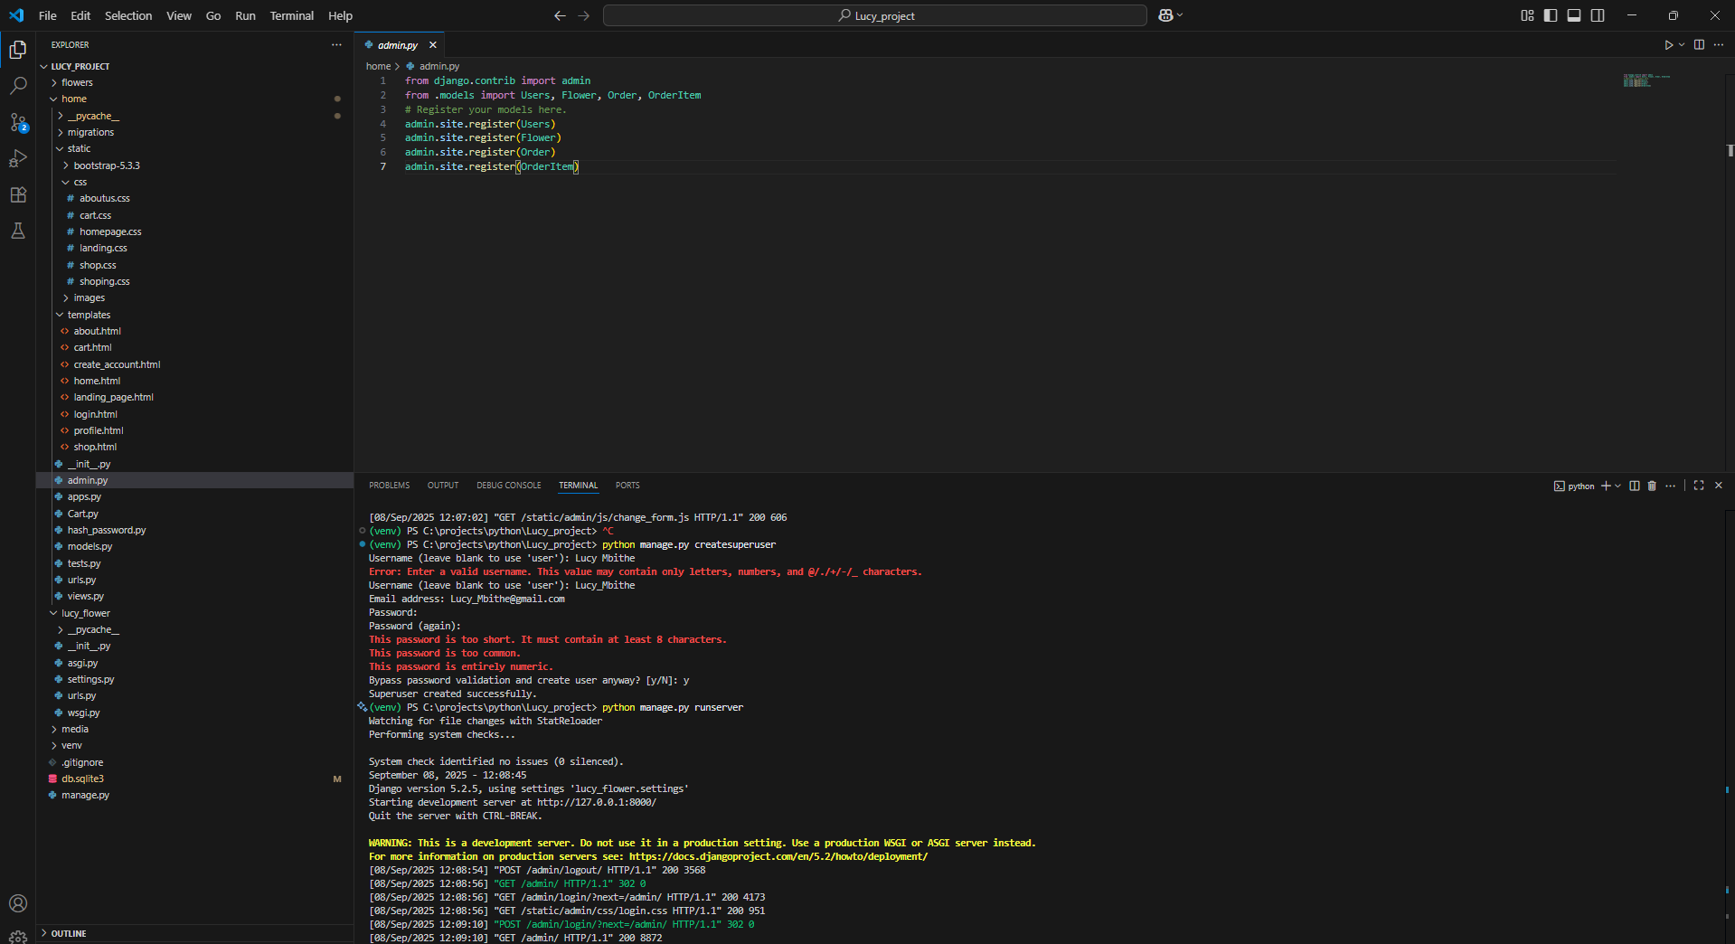
Figure 8Admin models register

2.1.4 Content page
This is where the flowers posted by the admin will appear
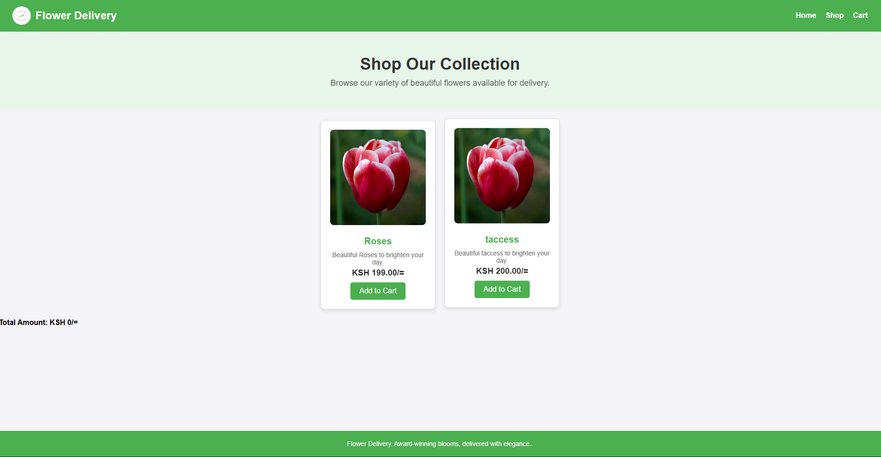
Figure 9Content page

Content page UI code
Below is my content page/shop page UI code
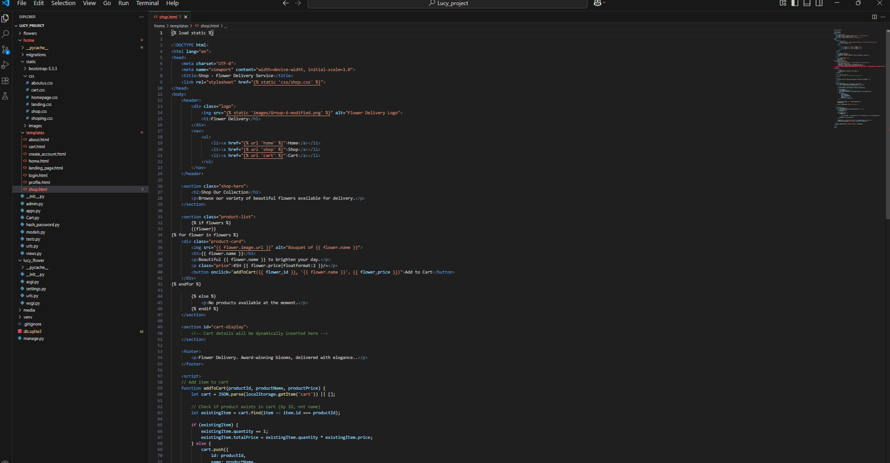
Figure 10Shop page

Cart page
Below is my cart UI page

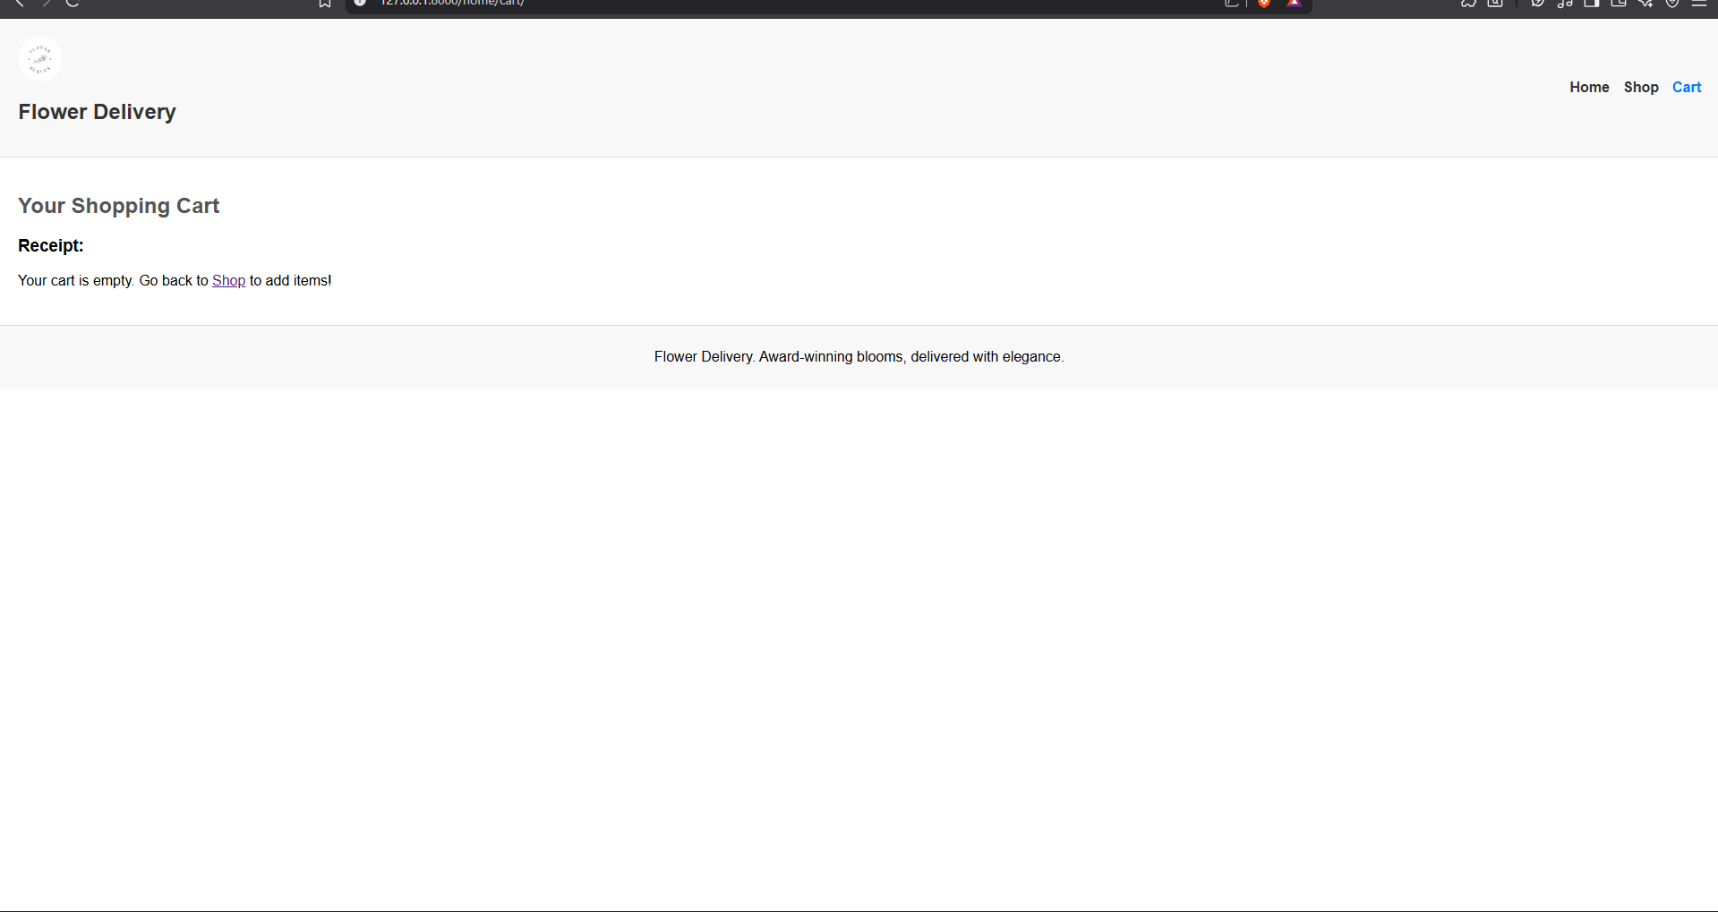
Figure 11Cart UI

Cart UI code
Below is my cart UI code
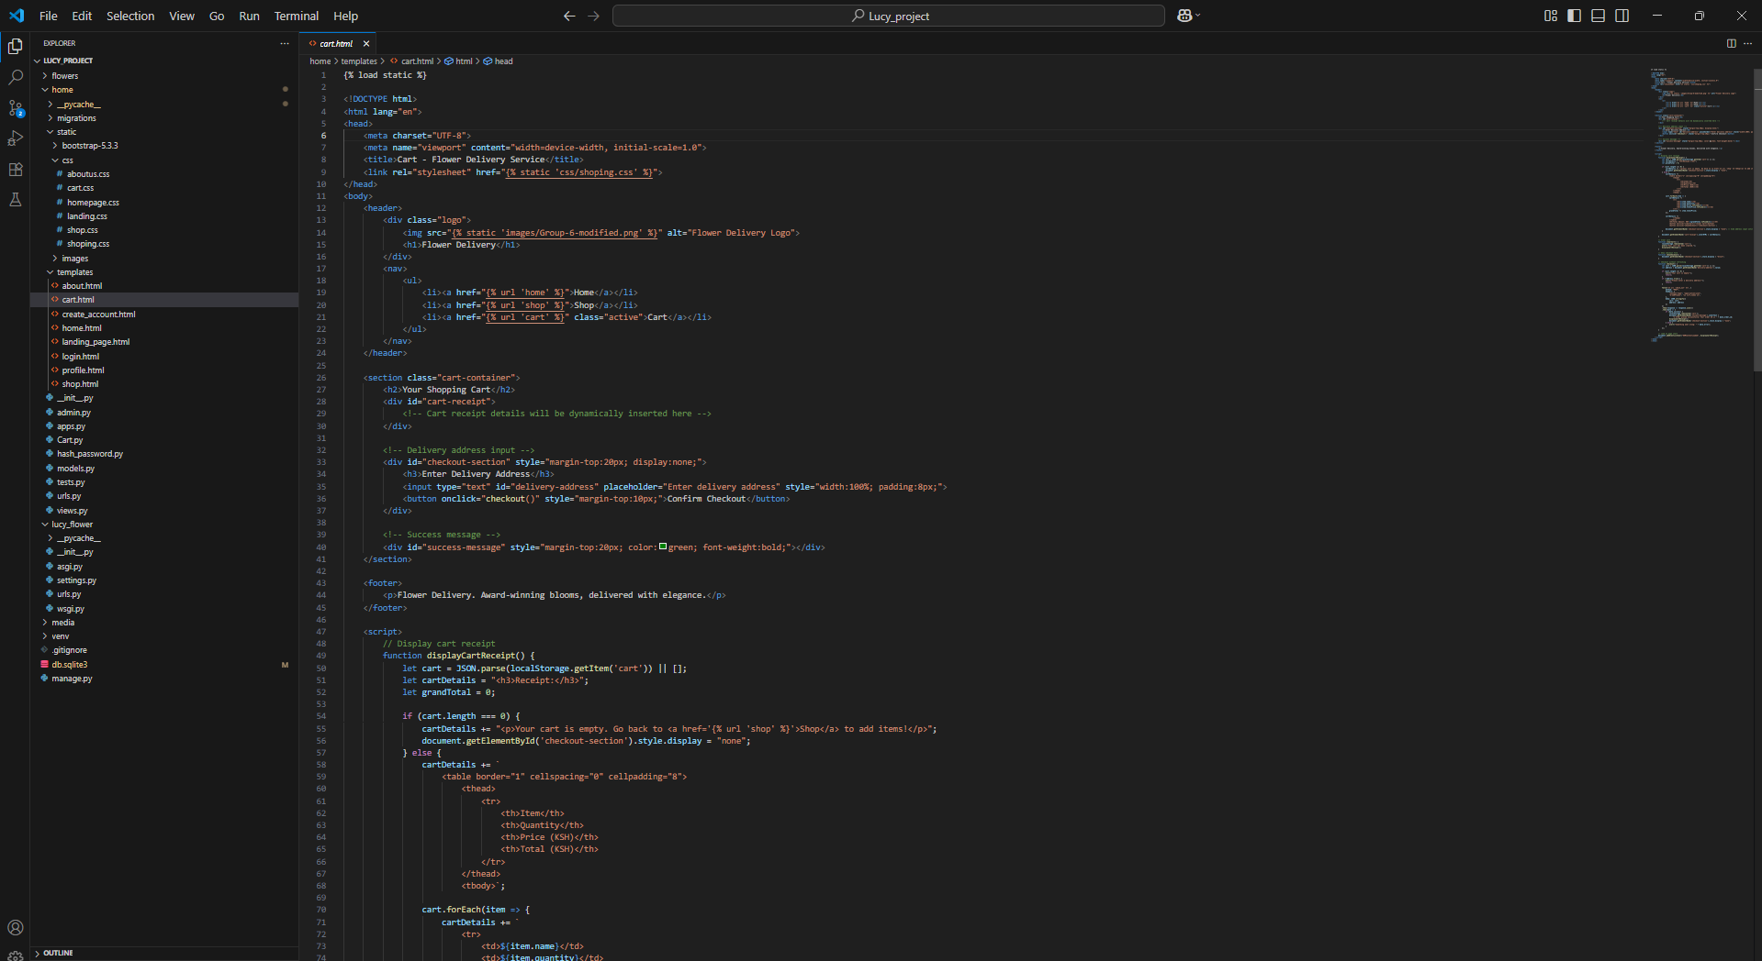
Figure 12: Cart UI code

My orders/Profile Page UI
In this section the user will be able to keep track of his/her own orders as shown below
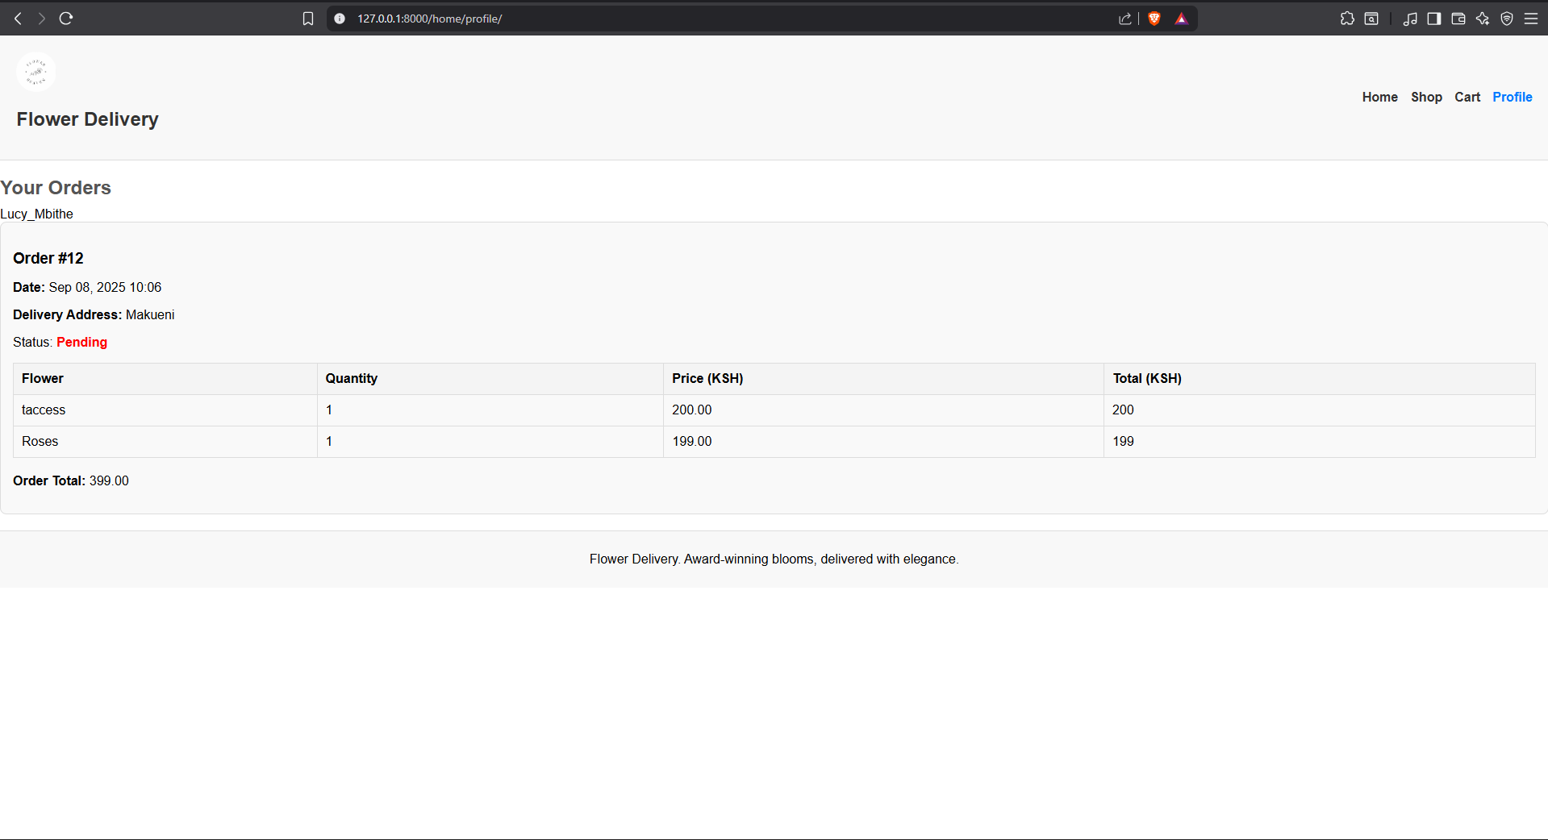
Figure 13orders

Orders UI code
Below is my orders ui code

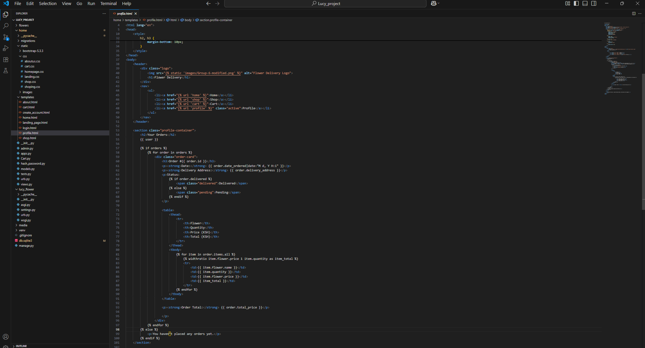
Figure 14: Orders code

Chapter Three: Backend (Logic ) Implementation

3.1 Account Creation Process

Below is the pseudocode illustrating the account creation process

User Enters his credentials (Email,username,Password)

The user clicks the Create Button
System will check whether the account already exist(it will check whether the Email exists in the DB)

If the Email doesn’t exist in the Db:
The system will display a success message and advise you to login
Else:
System will display an error message
System will advise you choose another email. Below is the pseudocode illustrating the Account Creation Process

Figure 15: Authorization Flowchart

3.1.1 Account creation Code

Below is account creation backend code
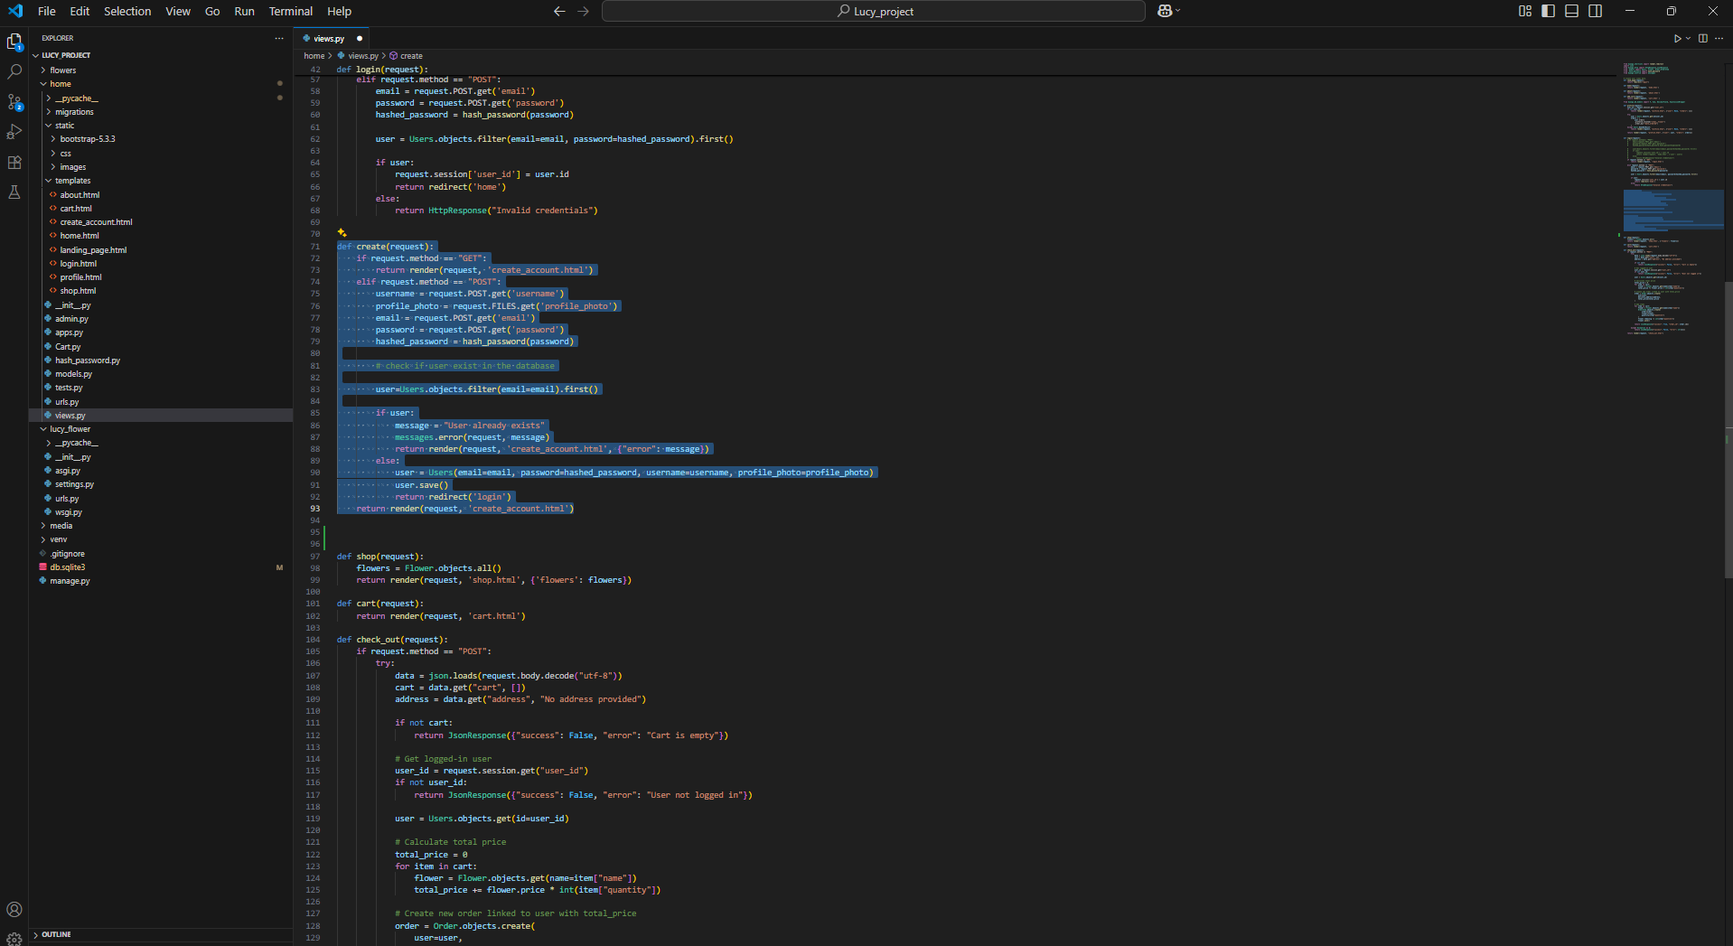
Figure 16: Create account code

3.2 Log in Process

Below is the pseudocode illustrating the login Process
User select the login option
User enters login credentials
User clicks Login button
System verifies the correctness of details
If all the details provided are correct:
session will be set using email provided
User will be redirected to homepage
Else:
Error message will be displayed
User will be redirected to login page again

The figure below is a flowchart representing the process

Figure 17: Login flowchart

3.2.1 Login logic Code

Below is my login logic code

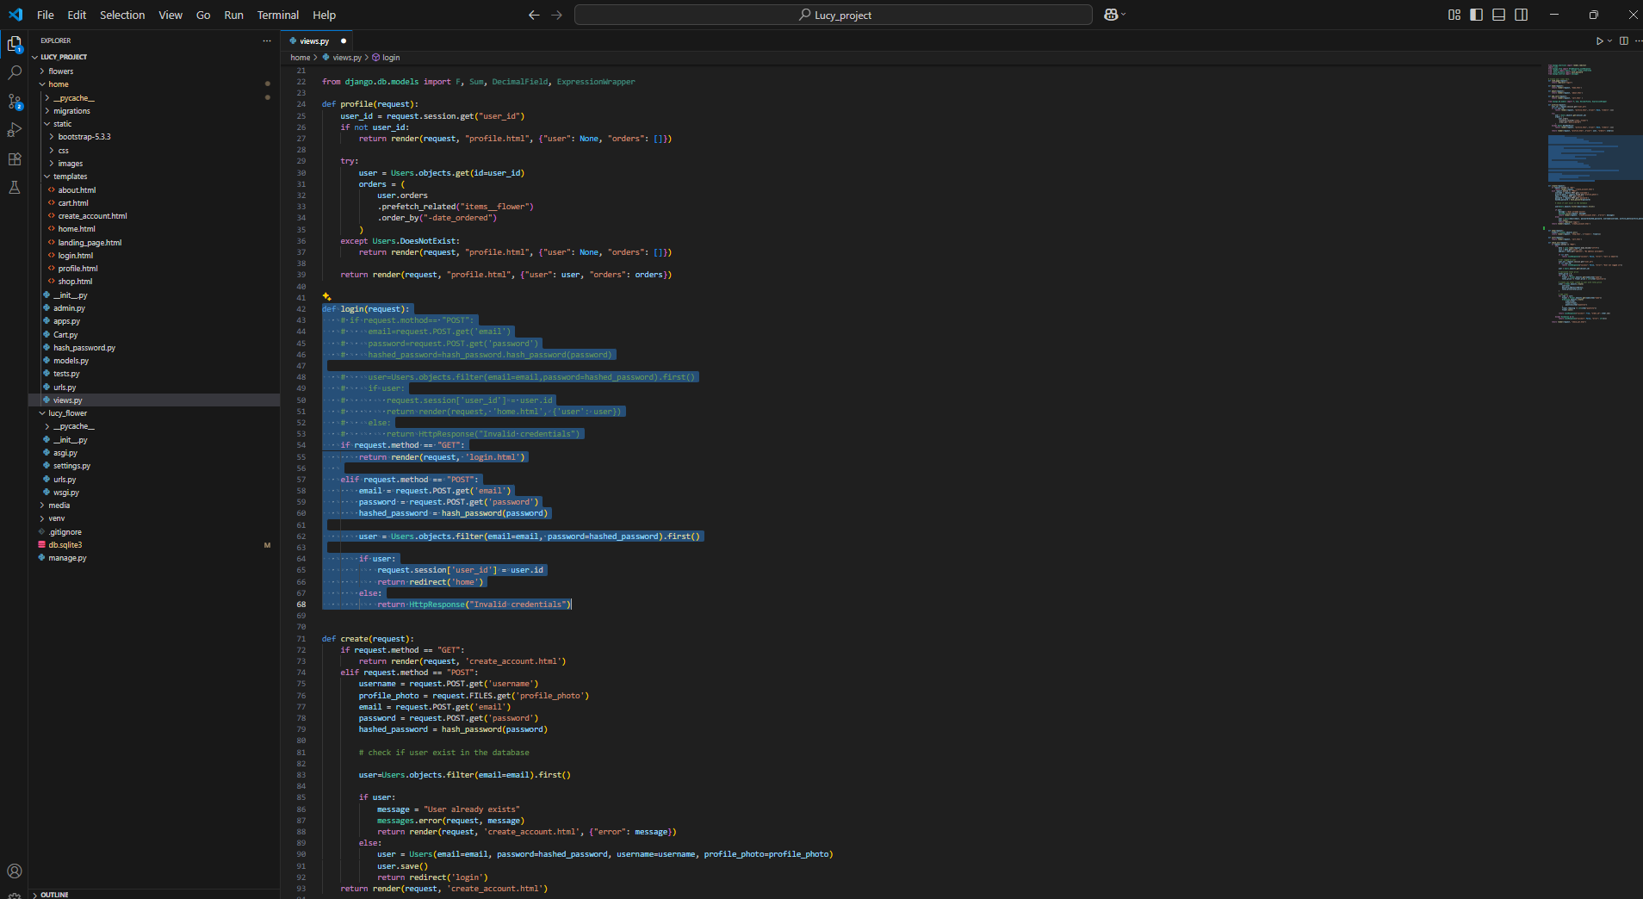
Figure 18: Log in code
3.3 Content/Flower Posting

My system accepts 2 content format which are: text format/content and Image content
When the server receive the data it saves the image to the file to the “image folder”, the path is corresponding to it is the one to be saved in the database

Figure 19: Post flowers

3.4 DataBase Implementation

3.4.1 Normalization
3.4.1.1 First Normal Form (1NF)
The unnormalized table may contain repeating groups, so we start with a flat structure:
| Id | Username | Email | Password | Date_joined | Profile_photo | User_type | Flower_id | Flower_name | Price | Description | Image | Remaining | Order_id | Delivery_address | Date_ordered | Delivered | Total_price | Quantity |
Problems here:
- User, flower, and order data are all mixed in one table.
- Multiple orders/flowers per user would cause duplication.

3.4.1.2 Second Normal Form (2NF)
We separate data into related tables to remove partial dependencies:
Users table
- Id
- Username
- Email
- Password
- Date_joined
- Profile_photo
- User_type
Flower table
- Id
- Name
- Price
- Description
- Image
- Remaining
Orders table
- Id
- User_id (FK → Users)
- Date_ordered
- Delivered
- Delivery_address
- Total_price
OrderItem table
- Id
- Order_id (FK → Orders)
- Flower_id (FK → Flowers)
- Quantity
Now, each table focuses on a single entity.

3.4.1.3 Third Normal Form (3NF)
We eliminate transitive dependencies, ensuring non-key attributes depend only on the primary key:
Users table
- Id (PK)
- Username
- Email (unique)
- Password
- Date_joined
- Profile_photo
- User_type
Flower table
- Id (PK)
- Name
- Price
- Description
- Image
- Remaining
Orders table
- Id (PK)
- User_id (FK → Users.Id)
- Date_ordered
- Delivered
- Delivery_address
- Total_price (derived but stored for performance)
OrderItem table
- Id (PK)
- Order_id (FK → Orders.Id)
- Flower_id (FK → Flower.Id)
- Quantity
In 3NF, there is no redundancy:
- User details are stored once in Users.
- Flower info is centralized in Flower.
- Orders are linked to users, and order items map many-to-many relationships between flowers and orders.

I used sqlite database in my system

Why I prioritized it:
- It is easy to learn and to write queries
- It is simple to understand and to configure with my system
- It is popular, this makes it easy to access learning resources
- It support many languages

3.4.1 Database Tables
Below figure represent database Models in my Django system
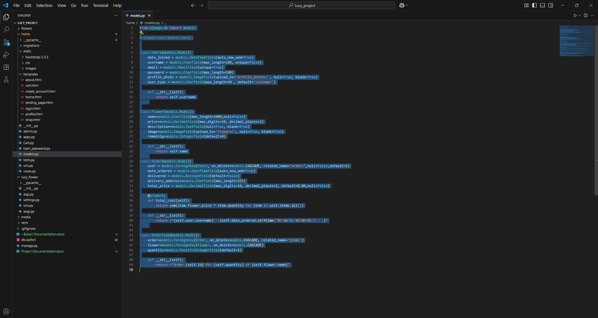
Figure 20: Database models presentation

The figure represent the user details table

Users table
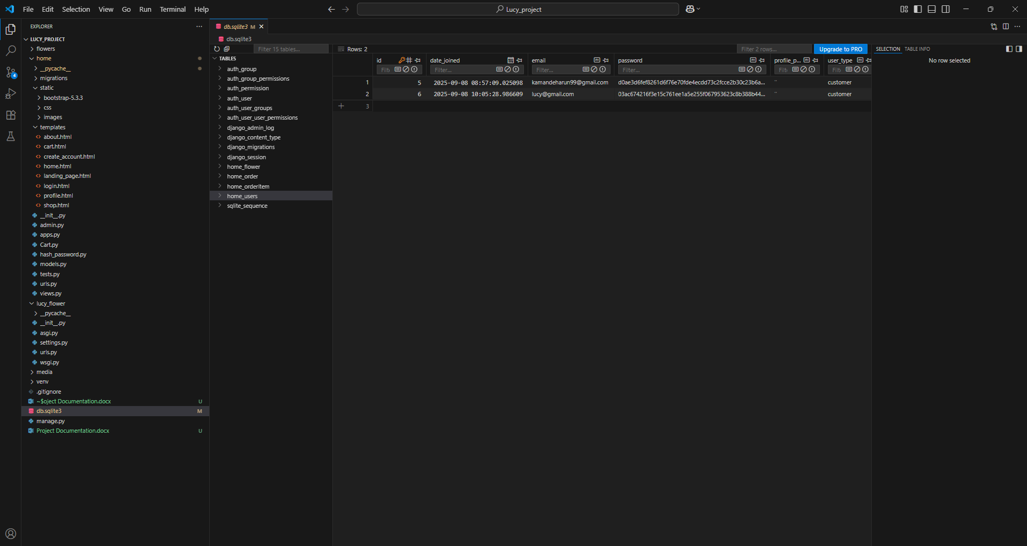
Figure 21: Users table

Flowers table

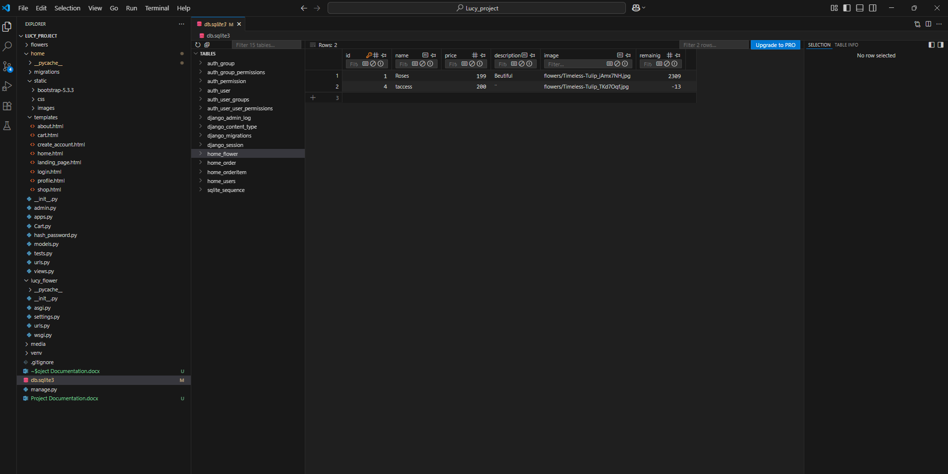
Figure 22: Flowers table

Orders table

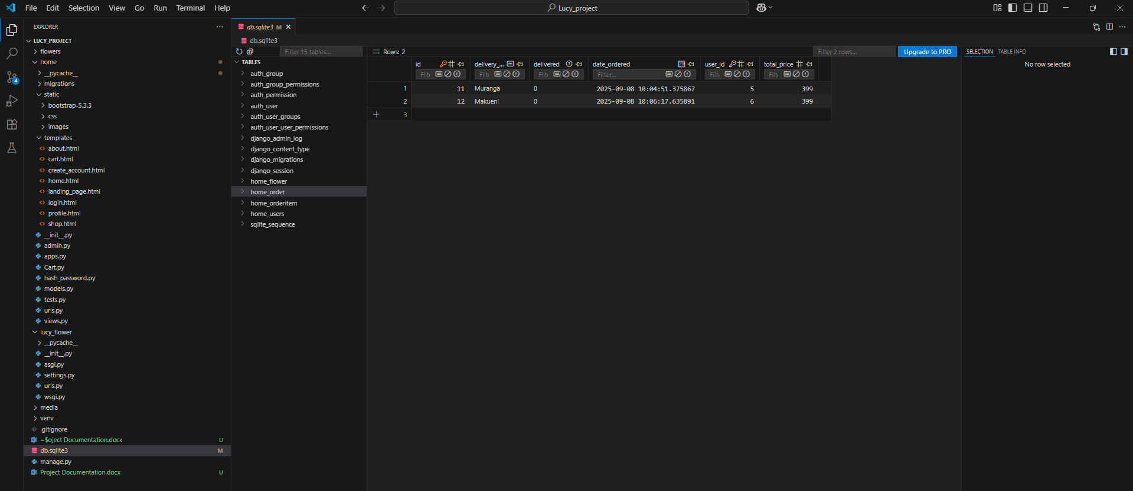
Figure 23: Orders table

3.4.2 System-to-Database Integration

The figure below represents the code that is integrating my system to sqlite database. Django provides Sqlite database by default

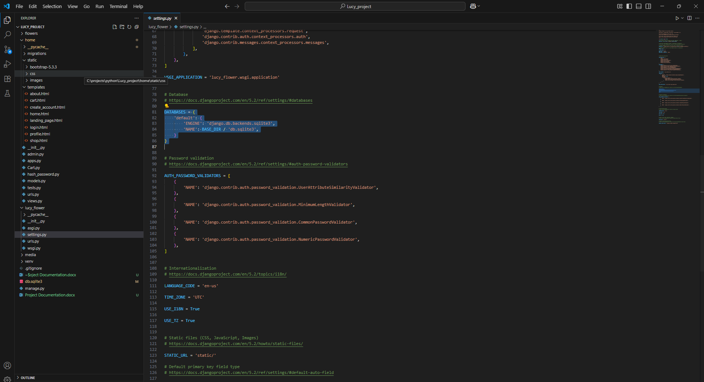
Figure 24: Database Integration

Chapter Four: Conclusion And Recommendations

4.1 Conclusion

In this project, I developed a flower selling and delivery system that allows users to create an account using a unique email and log in with their credentials. The system also allows the admin to post products with text and images, and customers can place orders for flowers to be delivered. From the project, I have learned how to design and implement a database, build user authentication, and connect different features to make the system functional.

4.2 Recommendations

Based on the work done, I recommend the following improvements for future development:
- The system should include stronger security features like two-factor authentication.
- It should have a product search and filtering option to make it easier for customers to find flowers.
- The system should be improved to handle more users and products as the company grows.
- A feedback and rating section should be included so customers can share their experiences.
- A mobile app version should be developed to make the system more accessible to all users.

References

Aarup, S. (2025, March 25). The Importance of Agricultural Education. The National FFA Organization. Retrieved from https://www.ffa.org/ffa-in-the-usa/the-importance-of-agricultural-education
Tiwari, S. P. (2022). Information and communication technology initiatives for knowledge sharing in agriculture. arXiv preprint arXiv:2202.08649. Retrieved from https://arxiv.org/abs/2202.08649
Valsamidis, S., Kazanidis, I., Petasakis, I., Kontogiannis, S., & Kolokithas, G. (2014). A framework for e-learning in agricultural education. Journal of e-Learning and Knowledge Society, 10(2), 89-99. Retrieved from https://ceur-ws.org/Vol-1152/paper33.pdf
Rohilla, S., & Chhimpa, R. (2024). Education and Training in Agriculture: Learning from Each Other. In Advancing in Extension Education: Innovations and Insights (pp. 67–77). Springer. Retrieved from https://www.researchgate.net/publication/378776440
United States Government Accountability Office (GAO). (2024, January 31). Precision Agriculture: Benefits and Challenges for Technology Adoption and Use. GAO-24-105962. Retrieved from https://www.gao.gov/products/gao-24-105962
Wikipedia contributors. (2025). Digital agriculture. In Wikipedia. Retrieved September 7, 2025, from https://en.wikipedia.org/wiki/Digital_agriculture

